Summarization of Data

Now that you have collected your raw data through taking a random sample, you need to summarize it in some way so that interesting features of the data can be seen.

Some data is easier to summarize than others. In fact there are four different levels of data.

The lowest level of data is called Nominal Data . The word “nominal” has its roots in the Latin word “nomen” which means “name”. In this type of data one simply records the name of the data element chosen. To illustrate, open the EXCEL file taste.xls which can be found in the EXCEL folder “MBA Part 1”. You should see data that looks like the sheet below:

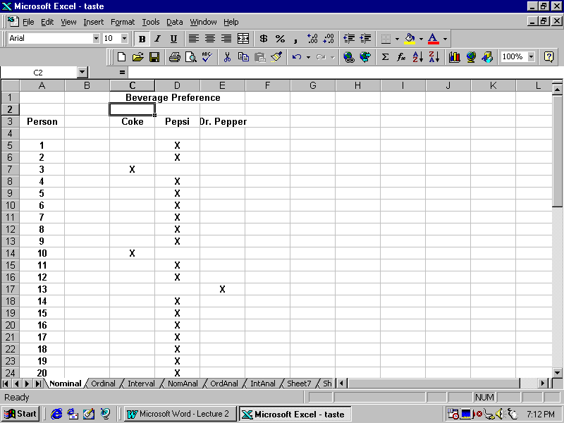
In this case we have given each randomly chosen person three containers containing one each of three beverages, Pepsi, Coke or Dr. Pepper, and asked them to pick which of the three they preferred. An “X” indicates which of the three beverages they preferred. Notice that this is just one way of representing the data. I could have just as listed the results of the tasting as P, P, C, P, P, P, P, P, P, C, P, P, D, etc. The only feature of the data recorded is the name. It is easy to turn this data into information by simply counting the number of times each beverage was picked. By scrolling down the worksheet you will find a summary table which looks like this:

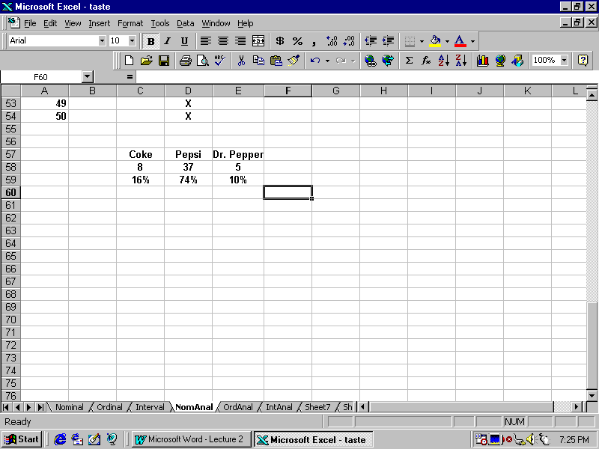

This shows a clear preference of Pepsi, with Coke coming in second followed by Dr. Pepper. It is easy to turn this into a graph. To do this highlight the label row and the row with the counts as below and then click on the “graph icon” next to the miniature globe icon at the top of the worksheet. Your screen should look like the following:

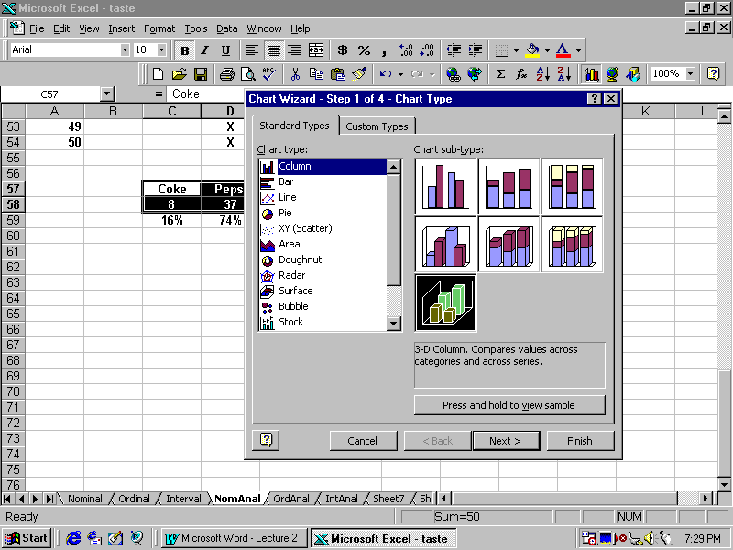
Notice that I have highlighted the three dimensional graph showing black and green colors. Now click on “Next” and when you get to the next screen click on “Next” again. This is the title option and I have filled in the titles for the graphs. If you wish you can click on “Legend” and remove the check mark in the box “Show Legend” by clicking on it, since the legend is not necessary for this graph. Your screen should now look like the following:

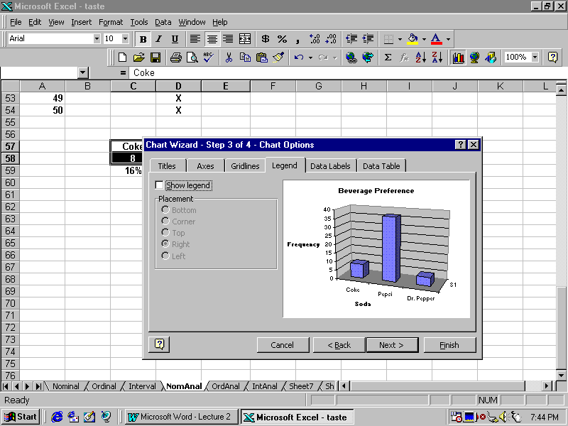
Click on “Next”. You are now given an option to make the graph appear on your worksheet or as a separate worksheet called a “Chart”. I have taken the latter option by checking the box as below:

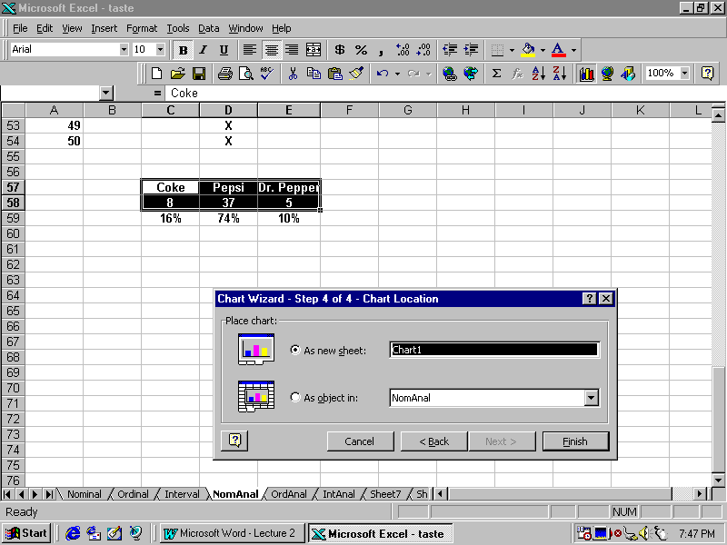
Now click on “Finish” and you should see the following:

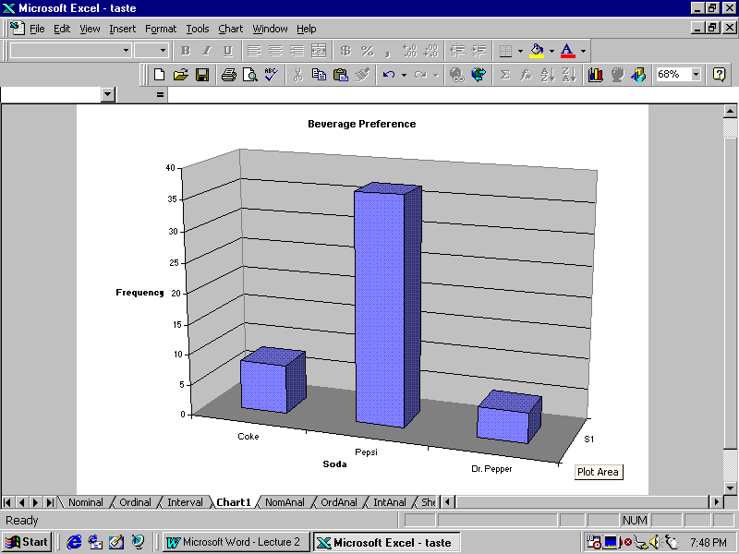
As an exercise, you might want to plot the percentage preference for each beverage rather than the frequency. (A complete plot of the data is given in the worksheet labeled “NomAnal” shown at the bottom of your display).

Go back to the worksheet and click on “Ordinal”. This is the same data except now we asked each individual to rank the three beverages in order of their preference rather than just telling us which they preferred. Such data is called Ordinal Data because within a person we can tell which is considered best, next best and least best. The word “Ordinal” comes from the Latin word “ordinalis”, which means ordered. The data should look like that shown below:

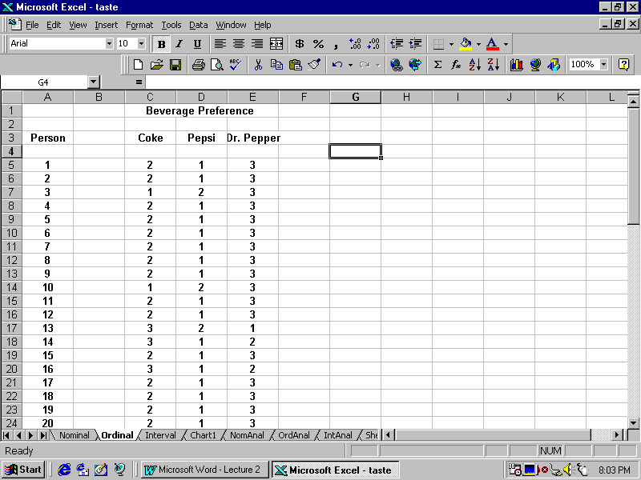
Scroll down to the bottom of the data. Your screen should like the following:

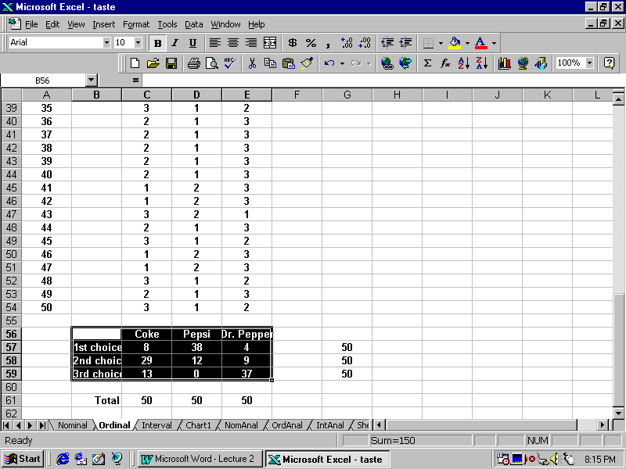

By following the same graphing procedure we followed for Nominal data, you should get a chart looking as below:

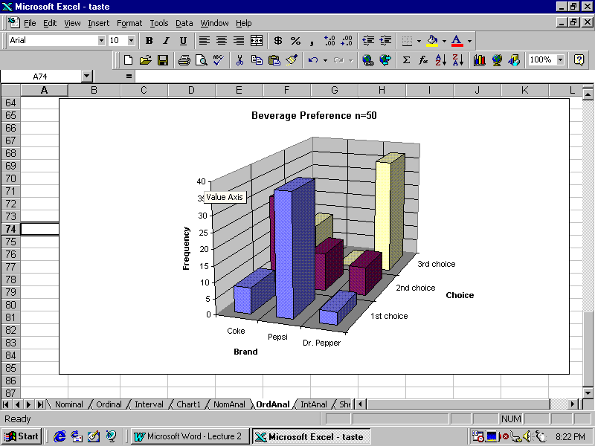

Now click on the Worksheet entitled “Interval”. This will display data which looks like that below:

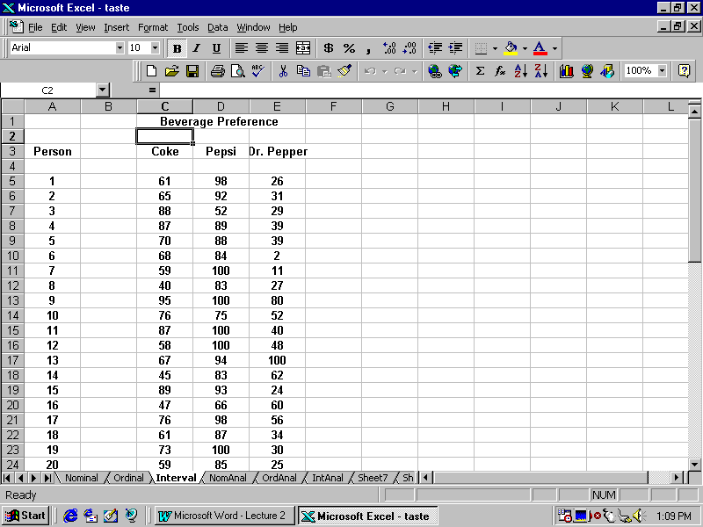

As you can see the data now looks different. What we actually did in the experiment was to ask each individual to rate each of the sodas on a 1 to 100 scale. This kind of data is called Interval Data because we can measure the degree of difference between the values. (The term “interval” comes from the Latin word “intervallum” which literally means between the walls). Notice that all of the following sequences would result in the same preference order of Pepsi, Coke and Dr. Pepper

Pepsi Coke Dr. Pepper

99 98 96
95 91 15
92 75 40
8 6 2

If you now try to draw the graphs as you did before you will get pictures which are not very illuminating. Give it a try.

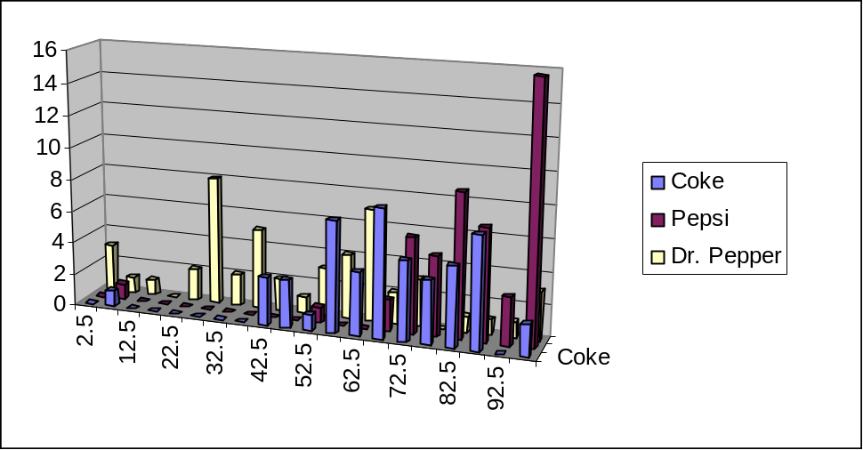

The problem is that with an interval scale we have too many possible values. In order to get a reasonable picture of the data, we need to use fewer possible values. One device for doing this is a frequency chart or a histogram.

Guidelines for Constructing a Histogram

There are no exact rules for constructing a histogram. But there are some guidelines, based on the way the human mind perceives information, which usually leads to graphs which show the patterns in the data. We will use the EXCEL term “bin” when referring to the intervals we will construct.

Rule 1 -- Use between 6 and 15 bins.

Rule 2 -- All bins should have the same width.

Rule 3 -- Use “natural” values for the bin width (e.g. 10-20, 20-30, etc)

Rule 4 -- Each observation should fall into one and only one bin.

EXCEL has a built in macro which will help us to construct histogram. To access it, click on “Tools”. You should get something that looks like the following:

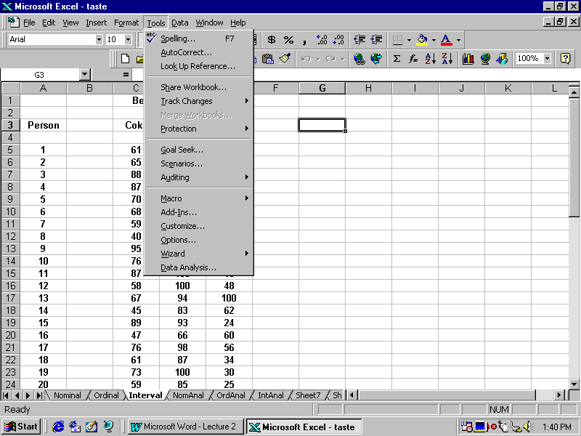
If your screen does not show “Data Analysis” at the bottom of the menu, click on “Add-ins” and then click on “Analysis ToolPak”. When you click on “Tools” again, the entry “Data Analysis” should appear.

Click on “Data Analysis” and you should a screen that looks like:

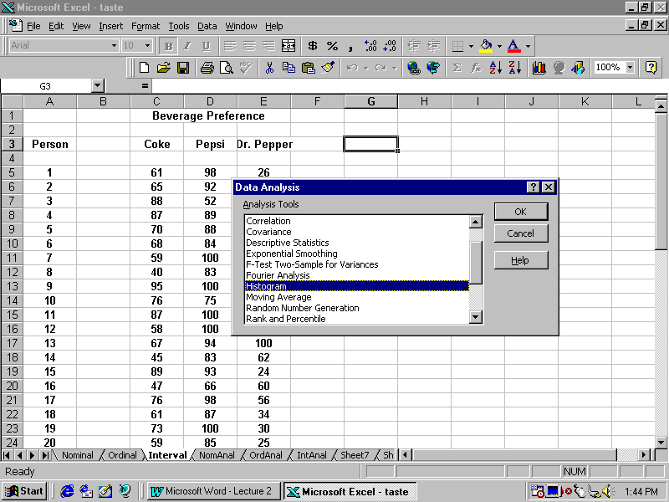
As you can see the phrase “Histogram” is highlighted. Click on “OK” and you should see something that looks like:

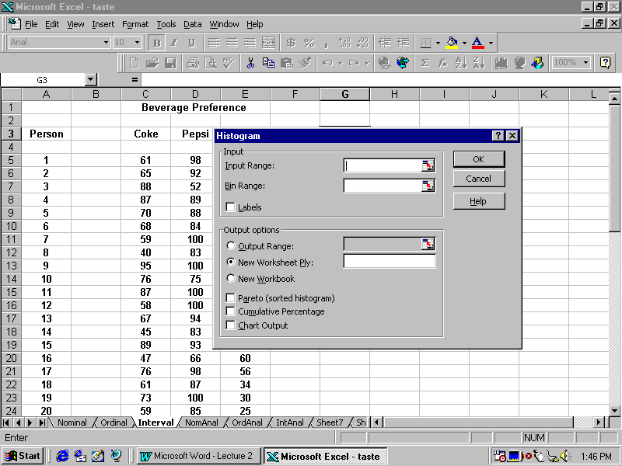
A minimum of three things must be entered:

Input Range --- where your data is located

Bin Range ---- where the bins or intervals are located

Output Range ---- where you want the results to be placed

You enter these values by highlighting the ranges of interest.

I will use bin ranges of 0-10, 10-20, ….., 90-100.

First I will enter the data range for Coke, as shown below:

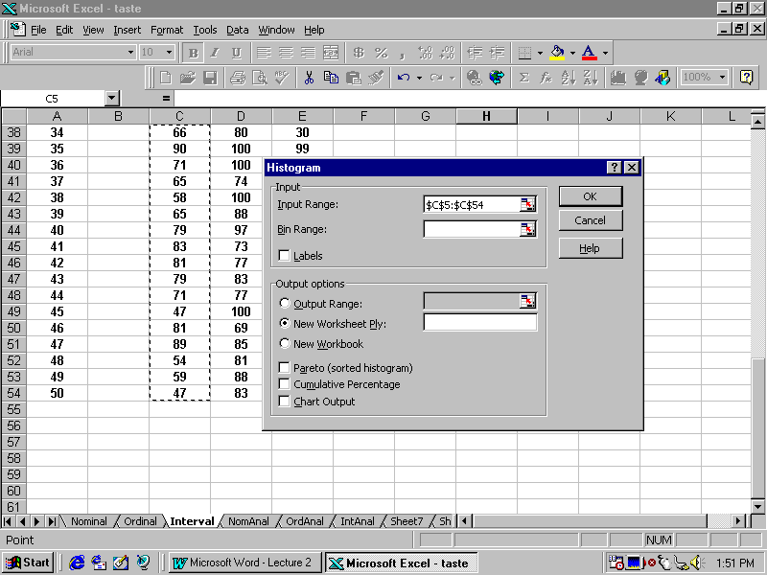
Now I will enter the Bin Range as shown below:

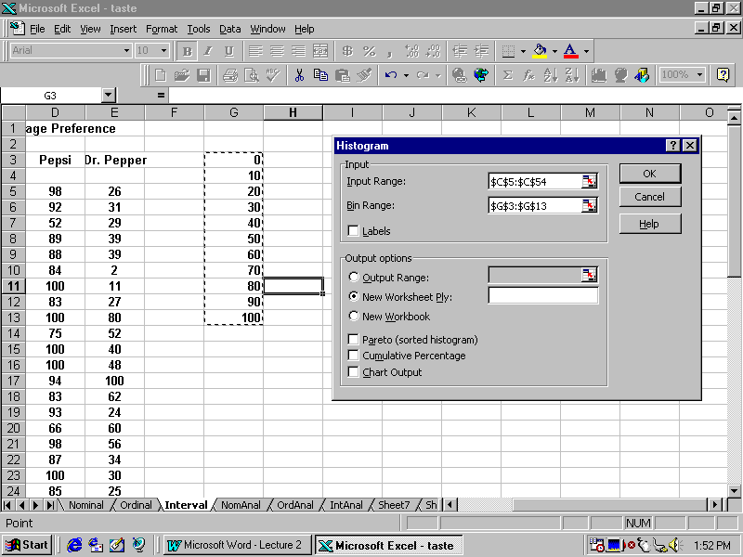
Finally, I will enter the upper left hand edge of where I want the output to go, as shown below:

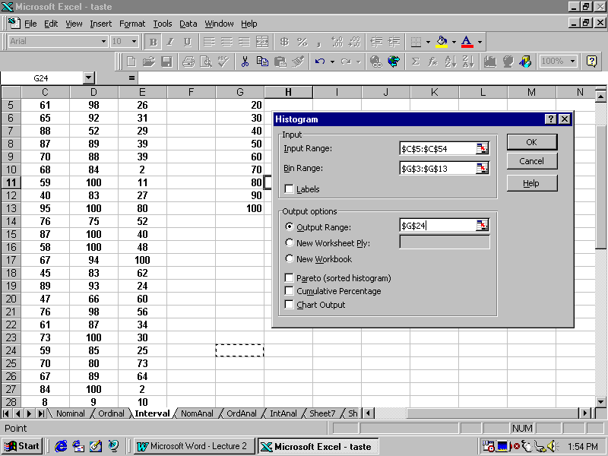
Now click on “OK” to get results as shown below:

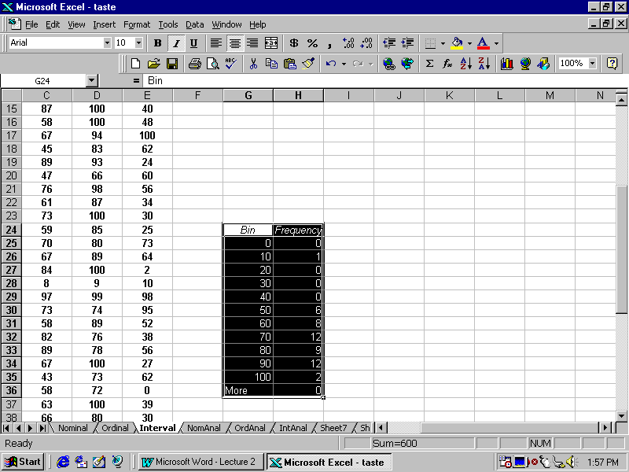
This indicates that there is 1 value in the data between 0 and 10, 0 values between 10 and 20, ……, and 2 values between 90 and 100. I can clean up this data by adding some extra columns to make it look like the following:

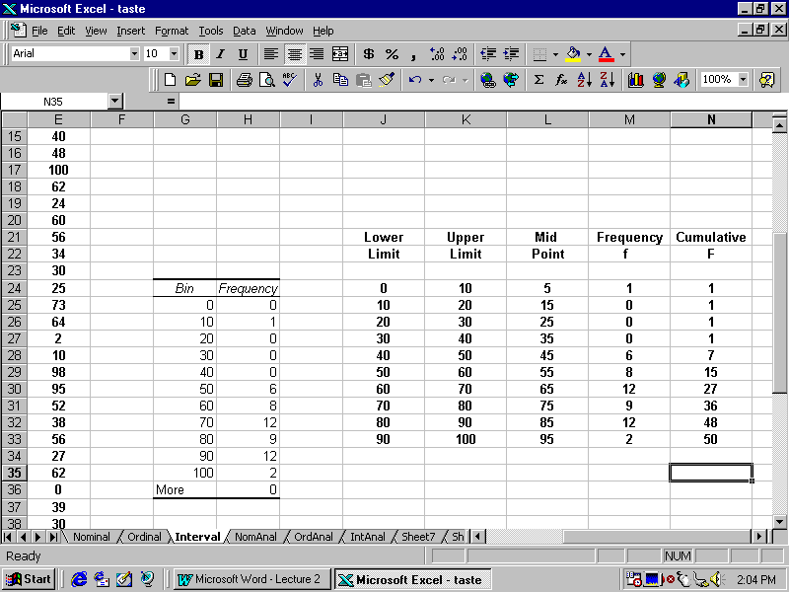
I can graph the histogram by the same procedure as before, highlighting the midpoint and frequency columns as shown below:

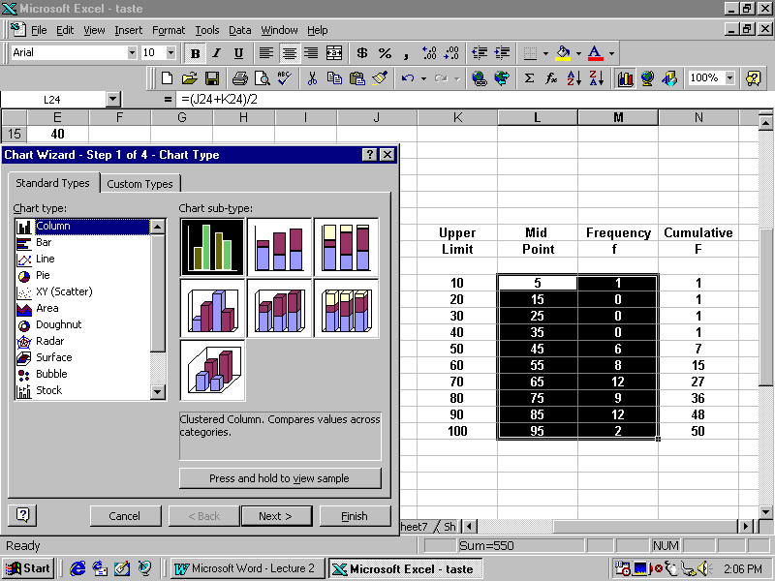
After hitting next, EXCEL thinks we want to graph two columns rather than just the frequency column. To correct this situation, click on Series and delete Series 1. The steps are shown below:

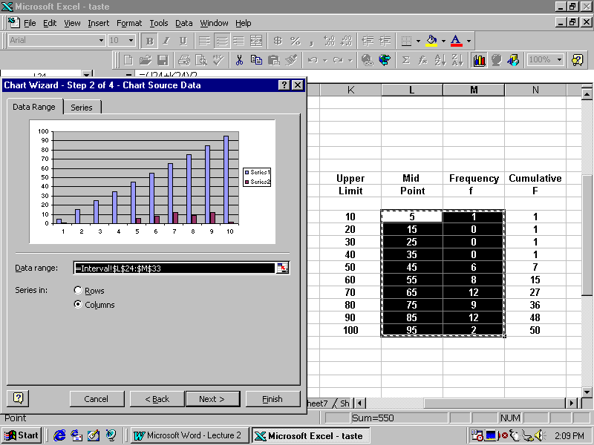
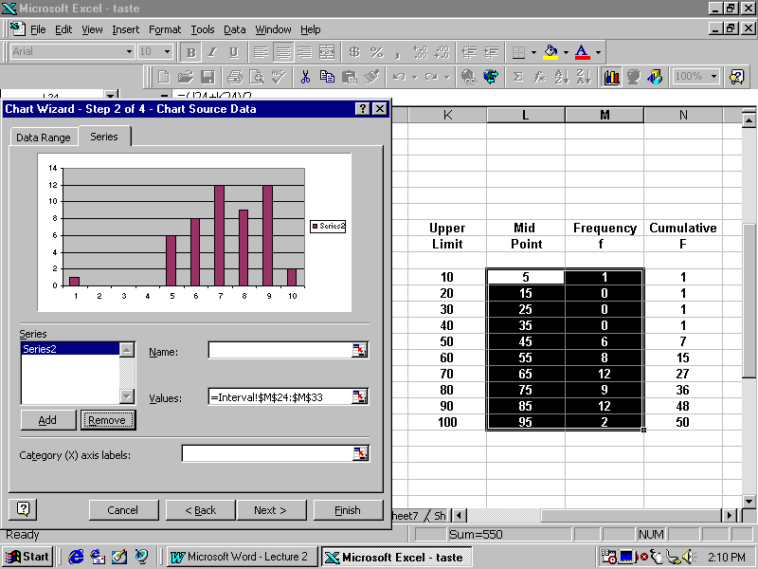
Now I need to tell EXCEL to use the midpoints as the labels for the x axis of the histogram as shown below:

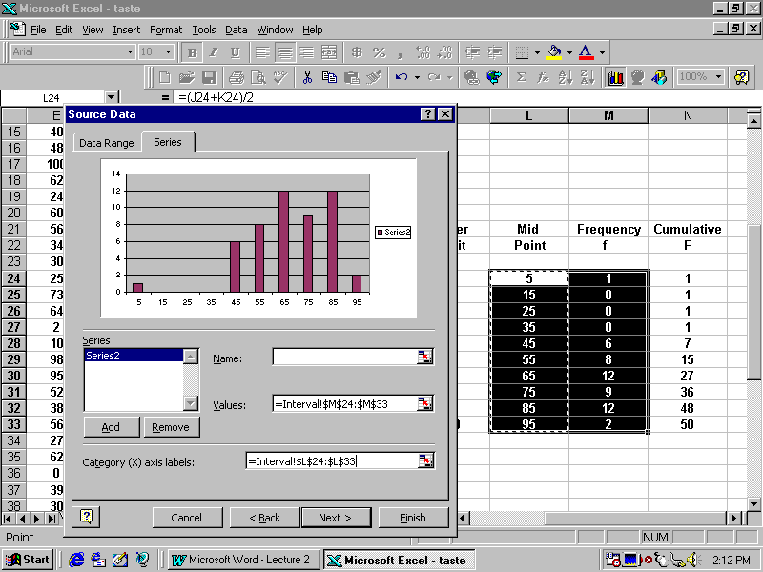
Now I finish by adding titles and removing the legend resulting in a histogram which looks like:

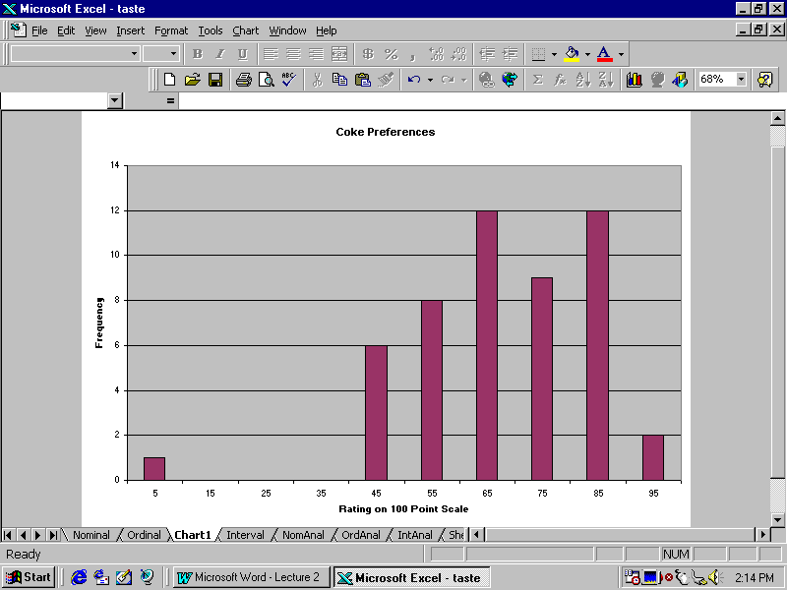
A histogram for Pepsi constructed in the same way looks like:

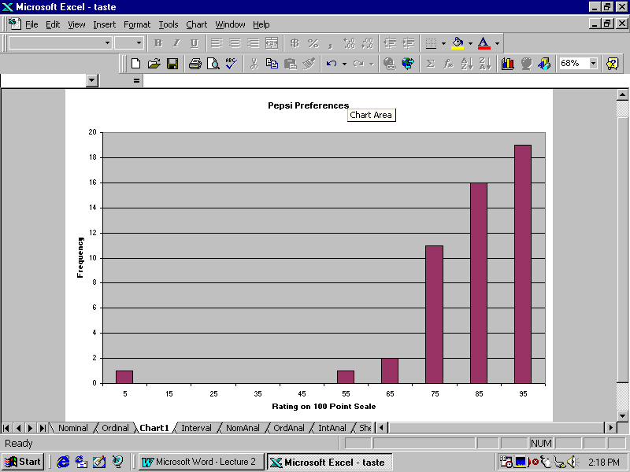
And the histogram for Dr. Pepper would look like:

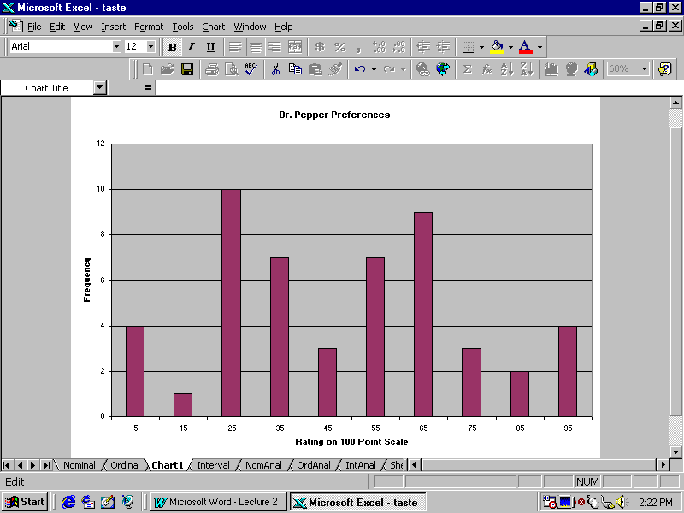
Raw Data on cost of VCR Repairs:

20.10 | 24.65 | 27.05 | 30.55 | 35.15 | 40.57 | 45.12 | 56.13
20.45 | 24.89 | 27.14 | 31.20 | 35.25 | 40.82 | 47.03 | 57.93
20.69 | 25.04 | 27.50 | 31.55 | 36.00 | 41.36 | 47.82 | 58.64
21.10 | 25.25 | 28.60 | 32.15 | 36.48 | 41.85 | 48.31 | 60.75
21.45 | 25.33 | 28.75 | 32.43 | 37.49 | 42.11 | 49.60 | 63.12
21.65 | 25.60 | 28.83 | 33.12 | 37.85 | 42.35 | 50.50 | 64.50
22.14 | 25.75 | 29.15 | 33.68 | 38.60 | 43.57 | 51.00 | 66.78
23.45 | 26.27 | 29.15 | 34.26 | 38.76 | 43.66 | 53.41 | 68.72
23.69 | 26.41 | 30.00 | 34.52 | 39.46 | 44.24 | 54.45 | 72.89
24.53 | 26.74 | 30.20 | 34.67 | 39.51 | 45.10 | 55.16 | 78.80

First Frequency Distribution:

Start | End | MdPt | f | F
15 | 25 | 20 | 12 | 12
25 | 35 | 30 | 28 | 40
35 | 45 | 40 | 19 | 59
45 | 55 | 50 | 10 | 69
55 | 65 | 60 | 7 | 76
65 | 75 | 70 | 3 | 79
75 | 85 | 80 | 1 | 80

Second Frequency Distribution:

Start | End | MdPt | f | F
20 | 30 | 25 | 29 | 29
30 | 40 | 35 | 21 | 50
40 | 50 | 45 | 15 | 65
50 | 60 | 55 | 8 | 73
60 | 70 | 65 | 5 | 78
70 | 80 | 75 | 2 | 80

First Histogram:
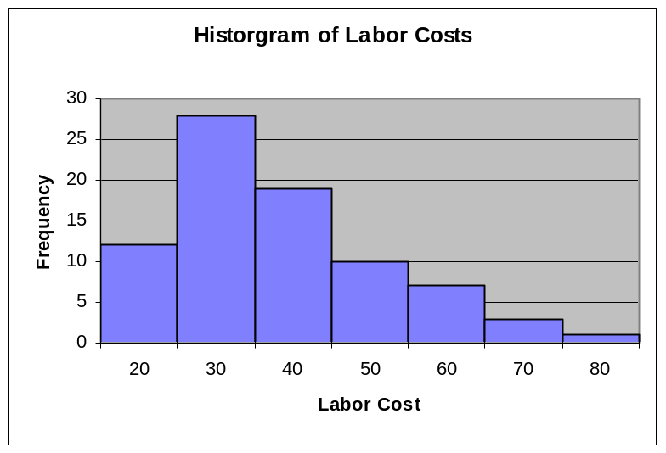

Second Histogram:
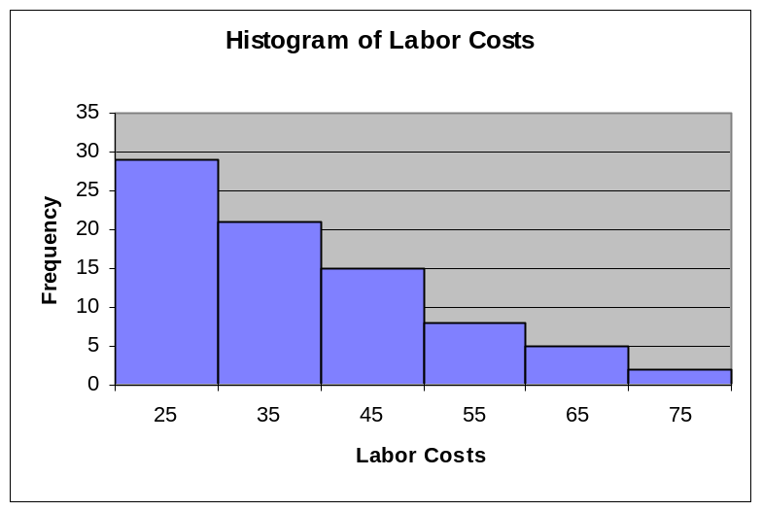

Characteristic Shapes

Right Skewed:

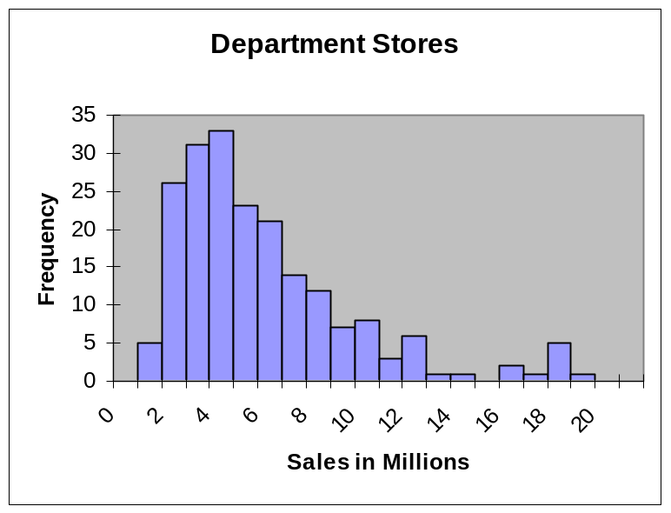

Left Skewed:

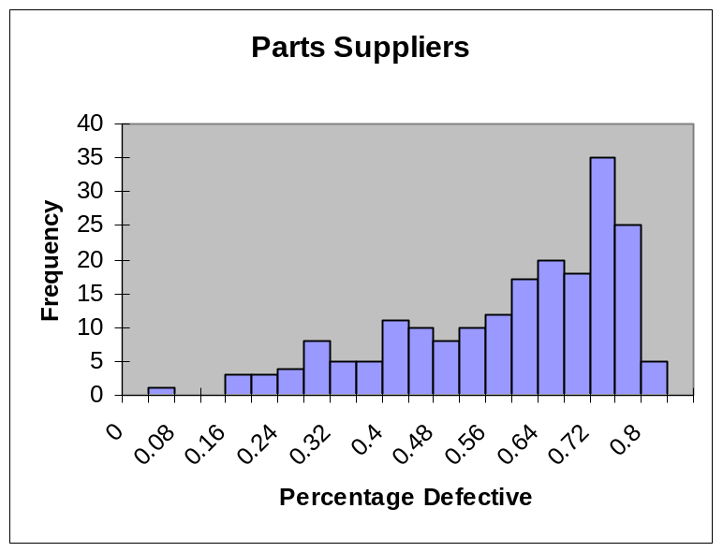
Uniform Distribution:

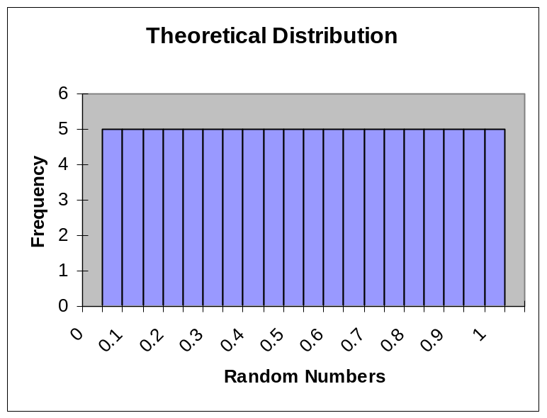

Bell Shaped Curve:

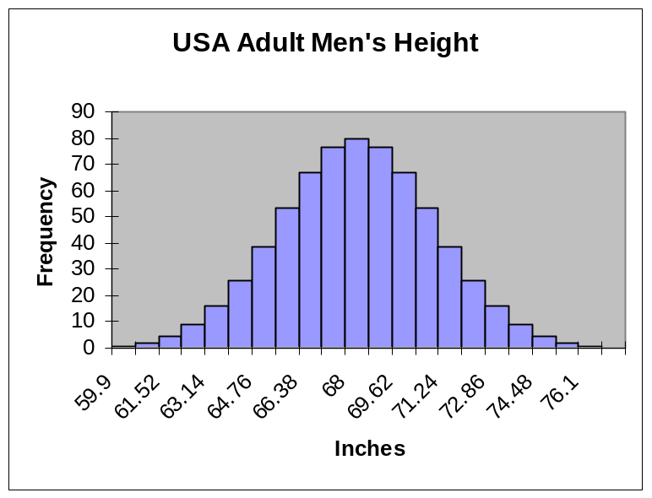
Bimodal Distribution:

